**Machine Learning**

**Logistic Regression**

It is the algorithm that is used to solve **classification problems based on probabilities.** If the probability is less than 50% then it assign to another class else it’s more than assign to another class based on this we can say that Logistic Regression is a **binary classification.**

It is a part of supervised ML where we will have feature column and label column but only one difference is that **our label column will have values 0 or 1 so it is called binary classifier.**

Example: Let’s consider the students attendance my input column will be name, roll no., phone no., and my output column will be attendance i.e. present or absent marked as for present 1 and for absent 0.

Why linear regression will not work for logistic regression? The simple answer is “**In linear regression we always try to consider the best fit line with minimum error and if we apply the same thing in Logistic regression where we are calculating the probability which can be either 0 or 1 but what if I have outlier in my dataset then in linear regression it again try to create a straight line and soon as a result my probability can be >1 or <0 so too avoid this we will be using cost function whereas in logistic regression cost function is log loss.**”

Working with Logistic Regression:

If we calculate the probability by using the **straight line equation i.e. y = mx + c** as a result output may come above 1 or below 0 but we will not get the accuracy to get the accuracy we will be using something called **Sigmoid Function.**

Sigmoid Function: In order to **map the predicted value of probability we will be using sigmoid function. The sigmoid function will always tend the value between 0 to1.**

Function of sigmoid function:

1. Applying this it **ranges the value between 0 to 1** thus useful for calculating the probabilities for Logistic regression.
2. Simple way to introduce non linear model.
3. Derivative is easy to calculate.

Formula for sigmoid function:



Basic diagram:



Cost function: In logistic regression cost function is nothing but **log loss** function. It plays a very important role in classification based metric based on probability. For a given problem a **lower log loss value means better prediction.**

Whenever we apply log loss function to the probabilities the **value tends to negative value. To overcome this we need to multiply the negative value with negative symbol** as shown below:

Note: If we buy a product then it represent to 1 else represent 0 so the actual class of ID5 is 0 so the probability for the class is (1-0.1 = 0.9)

|  |  |  |  |  |
| --- | --- | --- | --- | --- |
| ID | Actual | Predicted probability | Calculate probability | Correct probabilities |
| ID6 | 1 | 0.94 | 0-0.94 | 0.94 |
| ID1 | 1 | 0.9 | 0-0.9 | 0.9 |
| ID7 | 1 | 0.78 | 0-0.78 | 0.78 |
| ID8 | 0 | 0.56 | 1-0.56 | 0.44 |
| ID2 | 0 | 0.51 | 1-0.51 | 0.49 |
| ID3 | 1 | 0.47 | 0-0.47 | 0.47 |
| ID4 | 1 | 0.32 | 0-0.32 | 0.32 |
| ID5 | 0 | 0.1 | 1-0.1 | 0.9 |
|  |  |  |  |  |

To find the correct probabilities for each instance is:

**Log loss = 1/N ∑(LOG(Pi))**

Then table will represent

|  |  |  |  |  |  |
| --- | --- | --- | --- | --- | --- |
| ID | Actual | Predicted probability | Calculate probability | Correct probabilities | Log probability |
| ID6 | 1 | 0.94 | 0-0.94 | 0.94 | -0.0268 |
| ID1 | 1 | 0.9 | 0-0.9 | 0.9 | -0.0457 |
| ID7 | 1 | 0.78 | 0-0.78 | 0.78 | -0.1079 |
| ID8 | 0 | 0.56 | 1-0.56 | 0.44 | -0.356 |
| ID2 | 0 | 0.51 | 1-0.51 | 0.49 | -0.327 |
| ID3 | 1 | 0.47 | 0-0.47 | 0.47 | -0.49 |
| ID4 | 1 | 0.32 | 0-0.32 | 0.32 | -0.045 |
| ID5 | 0 | 0.1 | 1-0.1 | 0.9 | -0.0486 |

By applying the above formula my log probability represent by negative value. So to overcome we need to multiply by negative value.

**Log loss = -1/N ∑(LOG(Pi))**

|  |  |  |  |  |  |
| --- | --- | --- | --- | --- | --- |
| ID | Actual | Predicted probability | Calculate probability | Correct probabilities | Log probability |
| ID6 | 1 | 0.94 | 0-0.94 | 0.94 | 0.0268 |
| ID1 | 1 | 0.9 | 0-0.9 | 0.9 | 0.0457 |
| ID7 | 1 | 0.78 | 0-0.78 | 0.78 | 0.1079 |
| ID8 | 0 | 0.56 | 1-0.56 | 0.44 | 0.356 |
| ID2 | 0 | 0.51 | 1-0.51 | 0.49 | 0.327 |
| ID3 | 1 | 0.47 | 0-0.47 | 0.47 | 0.49 |
| ID4 | 1 | 0.32 | 0-0.32 | 0.32 | 0.045 |
| ID5 | 0 | 0.1 | 1-0.1 | 0.9 | 0.0486 |

Model evaluation:

After developing the model we need to predict the accuracy or check how effectively the model works for that we need to follow:

* Accuracy
* Recall
* Precision
* F1 score
* Specifity
* AUC (Area under curve)
* RUC (Reciver Operator Characteristic)

Confusion Metrics:

A typical confusion metrics look like:



Let’s understand the terms:

1. True Positive: At the time of prediction of model the output is positive and predicted output is also positive.
2. False Positive: At the time of prediction of model the output is negative but predicted value is positive.
3. False negative: Predicted result is negative by classification model but actually it’s positive.
4. False positive: Predicted result is positive by classification model but actually it’s negative.

Calculating accuracy score:

Formula: **accuracy = (TP+TN)/(TP+TN+FN+FP)**

Calculating recall or sensitivity:

Formula: **Recall = TP/(TP+FN)**

Calculating precision score:

Formula: **precision = TP/(TP+FP)**

Calculating F1 score:

Formula: **F1 score = 2*(precision * recall)/(precision + recall)**

**Decision Tree**

* Decision tree algorithm is one of the most **powerful algorithm used for both classification and regression purpose.**
* Easily work with complex data.
* This algorithm works by **dividing the whole dataset into a tree like structure based on some rules and conditions where the prediction takes place on those values.**

Let’s consider the example:

Suppose it’s Friday night and you are not able to decide wither to go out or not let’s consider the decision tree for it:



As pre the condition:

1. Check wither time is less than 10PM or not.
2. If yes then don’t go out.
3. If no the check your pocket that you have money or not.
4. If yes then go and enjoy
5. Else sit at home

From the above example we understand how the decision tree works.

**Decision tree for regression:**

* When we try to **work with decision tree regression, we will divide our feature column into distant and non-overlapping regions.**
  + Imagine you have a dataset with feature say x1,x2,x3,x4 and one output label column y. when you work with decision tree regression you will divide the dataset into distinct or unique without over lapping of information.
* Let’s consider the situation where **my feature values x1,x2, …Xp will divide into J distinct and non-overlapping regions R1,R2,..Rj.**
* The **region of R1,R2,..Rj are selected in such a way that to reduce the following sum of squares of residuals (RSS)**.



(Actual value – predicted value)^2

**Recursive binary splitting (Greedy approach):**

From the above example of dividing the dataset into tree structure is a time consumption process. To reduce the use of time the decision tree will opt for a technique called **Greedy approach in which nodes are divided into two regions based on the condition i.e. if the condition is satisfied only then it split in best split.**

For performing the **best split it will decide a threshold value (s) to divide the observations into different regions.**



The above mention process will have high chance of **over fitting** the training data as it is very complex.

**Tree Pruning:**

It is a **method of trimming down a full tree obtained through the above process to reduce the complexity and variance in the data.** As we regularized linear regression, we can also regularize the decision tree model by adding new term.



Where **alpha is non- negative tuning parameter, T is subset of original tree.** By using **cross validation such values alpha and T are selected for which our model gives lowest test error rate.**

This approach produces a good solution but not optimal solution.

**Post-pruning:**

* It is also known as **backward pruning**.
* It is a process where the **decision tree is generated first and then non-significant branches are removed.**
* Cross validation set of data is used to **check the effect of pruning and test whether expanding of a node will make an improvement or not.**
* If improvement it continue else it stop

**Pre-pruning:**

* It is also known as **forward pruning.**
* If will first remove **the entire non-significant branch from generating the tree.**
* It will be using the **condition to decide when should it terminate the split and generate the tree.**

In regression decision tree is made with the help of RSS (Residual sum of errors.

**Classification Decision tree:**

For tree construction we will be using **Gini impurity and entropy.**

**Entropy:**

* Entropy is **measure of randomness in the data**. In other words it gives the impurity present in the dataset.



* When the **step of splitting of our data comes into the picture we are trying to reduce the randomness in the data as a result my data will be cleaner as before**.
* If my data clean with respect to **same labels and randomness this is what called low entropy, whereas if my data is mixed with multiple labels and different randomness this is what called high entropy**.
* Let’s consider the condition there is **m observations** and we need to **classify them into 1 and 2 categories**. Let’s say **category 1 has n observations and category 2 has m-n observations** then
  + P = N/M
  + Q = M-N/M
  + We know that q = 1-p
* The entropy for the given set is
  + **E = -P * LOG2(P) – Q * LOG2(Q)**

**Information gain:**

* It calculates the **decrease in the entropy after splitting a node**.
* It is the difference **between the entropies before and after split**.



* Where T is the parent node before split and X is the split node from the T.

A tree based on entropy and information gain look like:



**Ginni Impurity:**

It is **measure of how often a randomly chosen element from a set would be incorrectly** **labeled** if it was randomly label according to the distribution of labels in the subset.

**It is calculated by multiplying the probability that a given observation is classified into correct class and the sum of all the probabilities when that particular observation is classified into wrong class**. Let’s suppose there is K number of classes and an observation belong to the class ‘i’ then the ginni impurity is given as:

Let’s the observation belong to class ‘i’, and its probability is ‘Pi’

Probability of observation belong to another class is

∑Px = 1-Pi

Then ginni impurity = ∑Pi * ∑Px

= ∑(Pi*Px) = ∑(Pi*(1-Pi)) = ∑(Pi – Pi^2) = ∑(pi) - ∑(Pi^2)

= **1-∑(Pi^2) formula for ginni impurity.**

Ginni impurity always lies between 0 and 1. Where 0 belong to impurity and 1 denoting random distribution. The node for which the ginni impurity is least is selected as the root node to split.

Tree based on ginnig impurity is



With the help of ginni impurity our decision tree will be constructed till the last.

**Different types of Algorithm in decision tree:**

ID3(Iterative Dichotomiser):

* It is one of the algorithms used to **construct decision tree for classification.**
* It uses information gain as **criteria for finding the root node and splitting them.**
* It only **accept categorical attributes**.

C4.5:

* It is the **extension of ID3 algorithm** and is better than ID3 as it deals with both **continous and descreet** values. It is used for classification purpose.

Classification and Regression algorithm (CART):

* It is the most **popular algorithm used for constructing decision tree**. It uses **ginni impurity as the default calculation for selecting root nodes, however one can use entropy as a criteria**.
* This algorithm will work for both regression as well as classfaction problems.

If we plot the difference between **ginni and entropy we can’t see much difference between them:**



Advantage of decision tree:

1. Used for both **regression and classification problems**.
2. Easily **methodology of splitting** is identified.
3. **Complex decision tree model are very simple** when visualized.

Disadvantage of decision tree:

1. A small change in the data can cause **instability in the model because of greedy approach.**
2. Probability of over fitting is very high.
3. It takes more time to train a decision tree.

**Cross Validations:**

Imaging that you have construct a model and its accuracy is 95% or 100% then you think that your model is good with high accuracy the answer to this question is No because the data what you have trained is known to the model and when you pass unknown data your model will not predict the good score this is what called over fitting. To reduce this over fitting we will use cross validations.

Cross validations is the resampling technique with the basic idea of dividing the training dataset into two parts i.e. training and testing. One part of data i.e. training is used to build the model and testing is used to predict the model.

Now if the test data is passed to the model and your score is well then you can say that your model is not over fitted.

Different approach in Cross Validation:

* Hold out Method: It is the most basic method of CV technique. It will simply divide the data into training and testing, with the help of training we will construct the model and testing data will be used for prediction purpose if the accuracy is good then your model is not over fitted and you can rely on it. But the evaluation based on the hold-out set can have high variance because it depend heavily on which data points end up in the training set and which in testing data.
* K-fold cross validation: To overcome the disadvantage of Hold-out method k-fold is used. The idea is simple it divide the dataset into k-sets of equal size then the first set is selected as the test set and rest k-1 sets are used for training the data. Error is calculated on the particular dataset. These steps are repeated. At the end CV error is given as the total errors calculated individually 

The variance in error decreases with the increase in ‘K’, the disadvantage of k-fold cv is that i.e. computationally expensive as algorithm runs from scratch for ‘k’ times.

* Leave one out of cross validations(LOOCV): It is the special case of k-fold CV where k become equal to n (number of observations). So instead of creating multiple sub set we are going to create only two sub set of data i.e. test data and rest will be my training data. The error is calculated for the test observations. Repeat the process again and calculate the CV error.



**Ensemble Technique**

Ensemble technique will **merge or aggregate the predictions from a group of multiple predictors,** which may come from classifier or regression problems and this type of output are far better than single predictors.

In generalized way “We can say that when we build a model the predicted value will be a single value as a result our vision will only be on that predicted value but what if we built a model that provide the multiple predicted values as a result we can compare the multiple predicted values and select the best predictor for the model.” This is what called ensemble method.

Let’s suppose we have **n** predictors and our feature column say **z1,z2,z3,z4…..zn** and the standard deviation is **σ**. We also know that variance is the sqrt of SD i.e. var(z) = σ^2

Let’s say average of all predictors is µ

µ = (z1,z2,z3,z4…zn)/n

if we use µ the predictor then the expected value still remain the same but now variance is

var(µ) = σ^2 and my variance will be decreased when we use average of all the predictors.

**Ensemble methods take multiple small models and combine their predictions to obtain more powerful predictive power.**

There are 3 ensemble techniques they are:

* **Bagging**
* **Boosting**
* **Stacking**

Let’s understand with the flow diagram what actually is ensemble technique do?

Collect the data 🡺 apply algorithm 🡺 multiple model development using multiple parameters 🡺 aggregating or merging them 🡺 selecting the best predicted score 🡺 using that model for prediction.

We will not have multiple different training sets on which we can train our model separately and combine their results. To apply these functionality bagging comes into the picture.

**Bagging (Bootstrap algorithm):**

Bootstrapping is the **technique of sampling different sets of data from a given training set by using replacement**. After **applying** the bootstrapping technique on **training dataset we will train our model on different on all the different dataset and aggregate the result.** This technique is known as bootstrap aggregation or bagging.

Def: Bagging is a type of **ensemble technique** where we apply a **single training algorithm** on **subset of training dataset** where the subset of data is **collected from training data** with the help of **bootstrapping technique i.e. replacement**. Once the algorithm is trained on all the subset of training dataset then **bagging make the prediction by aggregating all the prediction made by the algorithm** on different subset of data.

Bagging is also known as parallel model as we run all the models parallely and combine the result at the end.

In regression bagging prediction is simply the **mean** of all the predictions and in case of classifier bagging prediction are the **most frequent** predictions among all the predictions.

In bagging we are dividing the data into multiple groups where there is a chance of some percentage of data may not come under subset of taining data and when we evaluate the accuracy using that data the prediction accuracy is very low that what called **out of bag evaluation.**

Advantages of bagging:

1. Bagging will decrease the variance without increasing bias.
2. Works well because of sampling of training data is done with the help of bootstrapping.
3. Works well with small dataset.

Disadvantage of bagging:

1. Time consumption as dividing the training dataset sample and then developing the models and then aggregating the predicted value.

**Pasting** is also an ensemble technique similar to bagging with only one difference i.e. no replacement done while sampling the training data.

**Stacking:**

Stacking is an [ensemble learning](https://courses.analyticsvidhya.com/courses/ensemble-learning-and-ensemble-learning-techniques?utm_source=blog&utm_medium=comprehensive-guide-for-ensemble-models) technique that uses predictions from multiple models (for example decision tree, knn or svm) to build a new model. This model is used for making predictions on the test set.

**Boosting:**

Boosting is a sequential process, where each subsequent model attempts to correct the errors of the previous model. The succeeding models are dependent on the previous model. Let’s understand the way boosting works in the below steps.

1. A subset is created from the original dataset.
2. Initially, all data points are given equal weights.
3. A base model is created on this subset.
4. This model is used to make predictions on the whole dataset.  
   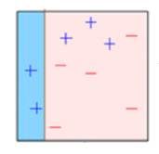
5. Errors are calculated using the actual values and predicted values.
6. The observations which are incorrectly predicted, are given higher weights.  
   (Here, the three misclassified blue-plus points will be given higher weights)
7. Another model is created and predictions are made on the dataset.  
   (This model tries to correct the errors from the previous model)  
   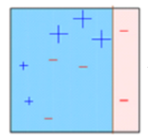
8. Similarly, multiple models are created, each correcting the errors of the previous model.
9. The final model (strong learner) is the weighted mean of all the
10. models (weak learners).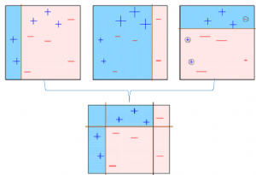

Thus, the boosting algorithm combines a number of weak learners to form a strong learner. The individual models would not perform well on the entire dataset, but they work well for some part of the dataset. Thus, each model actually boosts the performance of the ensemble.

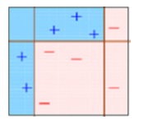

**Random Forest**

Introduction: Decision tree are one such models that have low bias but high variance as a result data is over fitted. So to overcome this situation bagging technique is used as a result it will decrease the variance, but bagging model is also an underlying model for decision tree. So to overcome we can also use an algorithm called random forest which is more convenient and well optimized for decision tree.

The main issue of not using bagging with decision tree is that there is not much independency of sample data as the result there exits a correlation.

The main purpose of random forest used in decision tree is that it overcomes the bagging model in the random forest as it makes a tweak in the working algorithm of bagging model to decrease the correlation in tree

The idea is to create a randomness while creation a tree which will help in reducing correlation.

**Working of random forest:**

When we built a decision tree with the help of random forest each time the split take place with the help of random sampling ‘m’ predictors are chosen from the total predictors ‘p’. For next split only ‘m’ predictors are allowed to be used for the split.



Form the given dataset different samples are created by bootstrapping and these samples are used to train different decision tree. Once the training is completed prediction is made using all the different models.

Prediction outcome:



As we have understood that when we are working with regression we will be calculating the mean of the outcome whereas in classification problem we will be considering the maximum reparative value.

Advantage of random forest:

1. Used for both classification and regression problems.
2. Model construction is a tree handling missing value is very easy.
3. Provide low variance

**Stacking:**

Stacking is a type of ensemble technique which combines the predictions of two or more models, also called as base models and use the combination as the input for a new model i.e. a new model is trained on predictions of the base models.



Suppose you have given a classification problem and you can use several models like logistic regression, SVM, KNN, Random Forest etc. The idea is that we will be using logistic regression, SVM, KNN for making predictions using those models. Now the prediction made by these models are used as input feature and applied on random forest to train and get new predictions.

Stacking improve the accuracy of training model by using prediction.

Steps in stacking:

1. Using k-fold cross validation split the data into 50-50.
2. Again select one 50 and respite it and soon.
3. Train the model with multiple algorithms and get the predicted output.
4. Apply that predicted output as input to the new model and predict the things.

**Support Vector Machine**

It is also called as SVM and used for both classification and regression. For regression it will be using support vector regressor and for classification it will be using support vector classifier.

It is used for small dataset only as it takes lots of time in processing.

The basic idea behind the SVM is finding the **hyper plane** that separate the features into different domains.

Example: You have an email account and in that email account you will be receiving the email from multiple persons along with spam. Now you want to classify it in the best way what will you do.

The solution to this is using SVM is I will try to construct a hyper plane that will divide my email spam and no-spam.



**Terminologies used in SVM:**

**Hyper plane is the function which is used to differentiate between features.**

The points closest to the hyper plane are called as the support vector points and the distance of the vectors from the hyper plane are called the margins.



The hyper plane is also called as margin maximizing hyper plane.

Let’s say that we have constructed a graph in m dimension space then its given as:



Where Wi = vectors (W0,W1,W2…Wm)

B = biased term(W0)

X = variables

**Types of kernels:**

1. Linear kernel
2. Polynomial kernel
3. Radial basis function kernel or Gaussian kernel

**Polynomial Kernel:**

In general polynomial kernel is defined as



Example: let’s say originally space is in 2 dimensional space such that

X1 = (a1, a2) and X2 = (b1,b2) now if we want to map our data into higher dimension let’s say in Z space with six dimensional it may take



In order to solve this dual SVM we would require the dot product of (transpose) Za^t and Zb.

Method1: traditionally we would solve this by using dot product



Method 2: Using kernel tick



**Radial basis function kernel (RBF)/ Gaussian kernel:**

RBF is the function whose value depends on the distance from the origin or from some point.



Using the distance in the original space we will calculate the dot product of X1 and X2.

Parameters:

C🡺 Inverse of the strength of regularization. If C value increases then over fitted model else C decreases then under fitted model.

Gamma🡺 used only for RBF kernel. If gamma value increases then over fitted model else C decreases then under fitted model.

Advantages and disadvantages:

Advantages:

1. Effectively for higher dimension.
2. Best algorithm when classes are separable.
3. Less outlier impact.
4. Suitable for extreme case of binary classification

Disadvantages:

1. For large dataset it required large amount of time to process.
2. Doesn’t perform well in case of overlapped classes.

**Bayes’s theorem:**

Based on statistical the mathematical formula is



Where A and B are probability of event and P(B) is not equal to 0

1. P(A/B) and P(B/A) is conditional probability
2. P(A) and P(B) are the probabilities of observing A and B respectively.

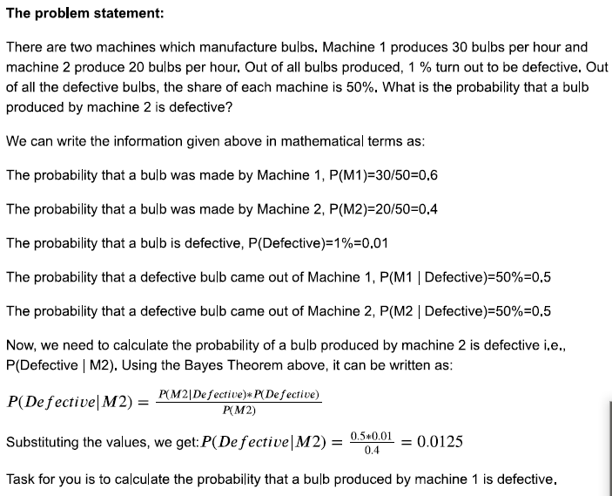

Algorithm steps:

1. Consider we have a binary classification problem and we have two classes in our data as shown below:



1. Now suppose if we are given a new data point, to which class does that point belong to?



1. Formula for a point X belong to class1can be written as



Where the number represents the order in which we are going to calculate different probabilities.

1. Similar formula cab be utilize for class 2
2. Probability of class 1 is

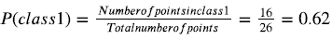

1. For calculating the probability of a point to be in a circle around the new point and see how many point (excluding the new point) lie inside the circle.



The point inside the circle are consider to be the similar points

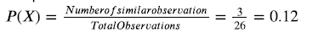

1. Now, we need to calculate the probability of a point to be in the circle that we have made given that it’s of class 1



1. We can substitute all the values into the formula in the step3

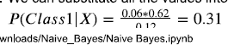

1. If we calculate the probability that X belongs to class2we will get 0.69 and It mean that it belong to class 2.

**Gaussian Naïve Bayes:**

When we are dealing with continuous data, one assumption is that the continuous values associated with each class are distributed according to Gaussian normal distribution.

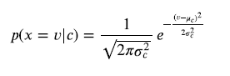

Advantages and disadvantages:

1. Fast for both training and prediction
2. Provide direct probabilistic prediction
3. Easy to interpret

Disadvantage:

1. Assume those features are independent always but i.e. not the case.

**K-Nearest Neighbors:**

KNN is the supervised learning algorithm used for both regression and classification purpose. KNN tries to predict the correct class of test data by calculating the distance between the test data and all training points. Then it selects the K points which are closest to the test data. Once the points are selected the algorithm calculates its probability (in case of classification) which is chosen based on highest probability. Whereas in regression problem the predicted value is the mean of the K training points.

Demo:

1. Given the training dataset and we have a new data we need to assign a class for it.



1. Now KNN will calculate the distance between the test data and the given training data. 
2. After calculating the distance, it will select the k training point which is nearest to the test data. Let’s assume the value of K = 3 for our example.



1. Now the nearest neighbor is selected as shown in the above figure. Let’s see in which class the test data will be assign:

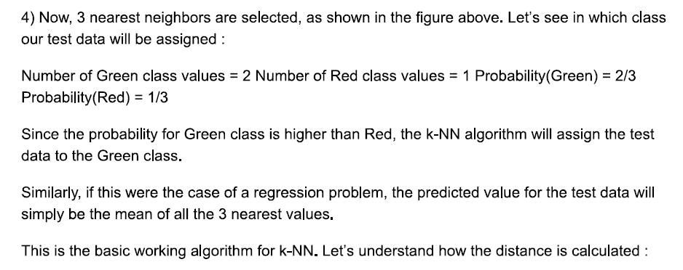

**Euclidean Distance:**

It is the most common method used to calculate the distance between two points. The Euclidean distance between two points P(p1,p2) and Q(q1,q2) is calculated as





For n-dimensional space the Euclidean distance is



**Hamming Distance:** It is the metrics that measure the number of mismatches between two vectors. It is mostly used for categorical data.



If we have the feature is categorical then the difference is 0 if we have same values else 1 if we have different values.

**Manhattan Distance:** It is also known as L1 norm, Taxcab norm, city block distance. The distance represent the sum of the absolute differences between the opposite values in vectors.



It is less influenced by outerlier than the Euclidean distance. With very high dimensional data it is more preferred.

**Lazy learner:** unlike other algorithm KNN will not work similar to that as KNN will wait for test data before model creation. Once the test data is provided then only it starts generalizing the training data to classify the test data. So lazy learner just store the training data and waits for test data, so it’s called lazy learner.

**Weighted nearest neighbor:** In weights KNN we assign weights to the K nearest neighbors. These weights are based on distance.

To choose the good value of K we need to calculate the optimum value of K such as cross validation error vs K curve and check accuracy for each value of K.

Advantage:

1. Maths behind this algorithm is simple
2. Less time consumption

Disadvantage:

1. finding optimum value of K
2. Expensive in testing phase.

Different way to perform KNN:

1. K-dimensional tree: It is a hierarchical binary tree, when this algorithm is used for KNN classification, It ranges the whole dataset in binary tree structure so that when test data is provided It will give out the result by traversing through the tree, which take less time than brute search.

The dataset is divided like a tree as shown in the above figure. Say we have 3D data (x,y,z). here we start with X then next level of split is done(Y) and then 3rd i.e. (Z). similarly in k-dimensional space how tree is form.









Once tree is formed, it is easy for an algorithm to search for the probability nearest neighbor just by traversing the tree.

The main problem with K-dimensional tree is that it gives the probability nearest neighbor but can miss out actual nearest neighbors.

**Ball tree:** It is also hierarchical data structure. These are very efficient specially in case of higher dimensions.

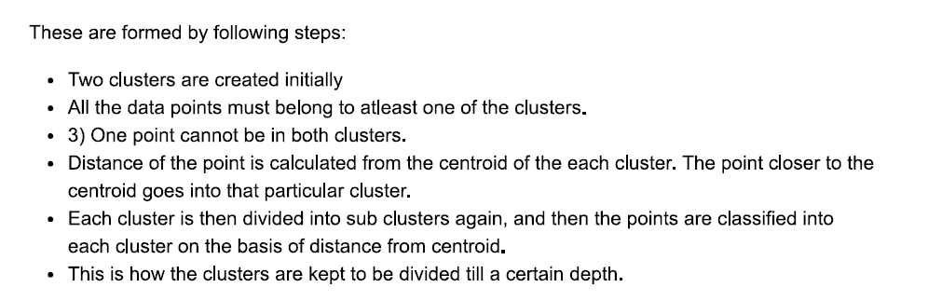

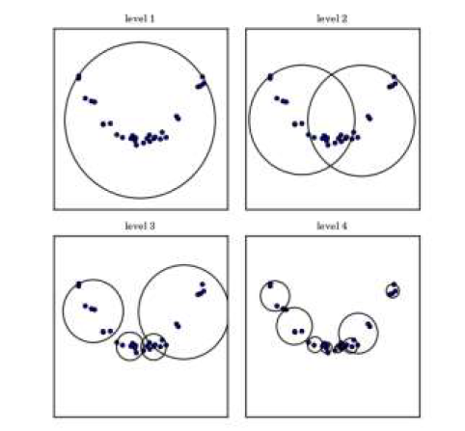 

The End

**Unsupervised Learning**

**Clustering:**

Imagine that you have given information of your area and your task is to identify the number of male and female with different age groups. The solution to this problem is that you will form different group based on their characteristics and similarities.

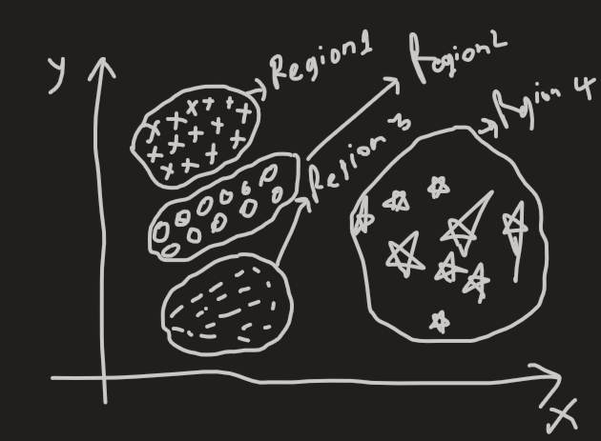

The process of identifying the similarities of object in the group and separating then into specific group is called **clustering.**

Clustering is an unsupervised approach which finds the structure/pattern in the collection of unlabeled data. A cluster is a collection of objects which are **similar** among them and are **dissimilar** to the object belong to different cluster.

Application:

1. For customer segmentation
2. Dimensional reduction
3. Anomaly detection
4. Search engines
5. Image segmentations

Main requirements:

* It should be scalable
* It should be able to deal with attributes of different data type
* It should be able to discover arbiter shape of clusters.
* Handle data with huge dimensions.

Approaches for clustering:

The clustering approaches can be classified into two categories:

1. Agglomerative clustering
2. Divisive clustering

**Agglomerative clustering:** This considers all the points as individual clusters and then finds out the similarity between two points and then forms a cluster and this process continuous till the last group of cluster left. This is also called the **bottom-up approach**.

**Divisive clustering**: This approach is opposite of agglomerative approach. It first considers all the points as a part of one big single cluster and in the subsequent steps tries to find out the clusters which are least similar to each other and then breaks the bigger cluster into smaller once. This is also called as **top down approach**.

**K-Means Clustering**: It is the approach in which the data is grouped into K distinct non-over lapping clusters based on their distance from the K centers. The value of K is needed to specify first and then the algorithm assigns the points to exactly one cluster.

Theory:

1. Let’s say that c1,c2,c3,..ck be the K cluster.
2. Then we can write that c1Uc2Uc32U…Uck = {1,2,3,..n} i.e. every data point in the data is allocated to a specific cluster.
3. The main idea behind **k-mean clustering is that the variation among the data points in the data set should be minimum.** With is cluster the variance is demoted by W(ck) hence variance should be minimized.
4. Formula for minimization is: 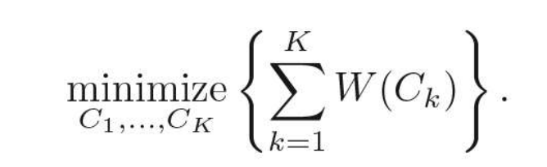
5. Next step is to determine the distance between the all the data points in the cluster and the same process is done for all the data points.
6. Formula is : 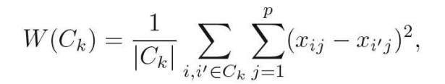
7. From the above steps we are firsts calculating the distance between all the points in the dataset then repeating if for all the clusters and then dividing it by the number of observations in the cluster to calculate the average value. **Here ck is the number of observation for K clusters. So ultimately your goal is to minimize the distance between each point in the cluster.**

Algorithm steps:

* Randomly assign K centers.
* Calculate the distance of all the points from all the K centers and allocate the points to cluster based on the shortest distance. The model’s **inertia** is the mean squared distance between each instance and it’s closet **centroid**. The goal is to have a model with low inertia.
* Once all the points are assign to the cluster, recompute the centroids.
* Repeat the above two steps until centroids stop changing and the cluster allocation of point become constant.

From the above description we know that we need to early specify the value of K. But the question how to get the value of K.

An **optimum value of K is obtained by using Elbow method**.

**Elbow method:**

This method is based on the relationship between the **within-cluster sum of squared distance (WCSS) also known as inertia and number of clusters.** It is observed that first with the increase in number of clusters WCSS will decreases steeply and then after a certain number of clusters the drop of WCSS is not prominted.

The point after which the graph between WCSS and the number of clusters becomes comparatively smoother in termed as the **elbow** and the number of cluster at that point are the optimum number of clusters as even after increasing the cluster after that point of variation is not decreasing much.

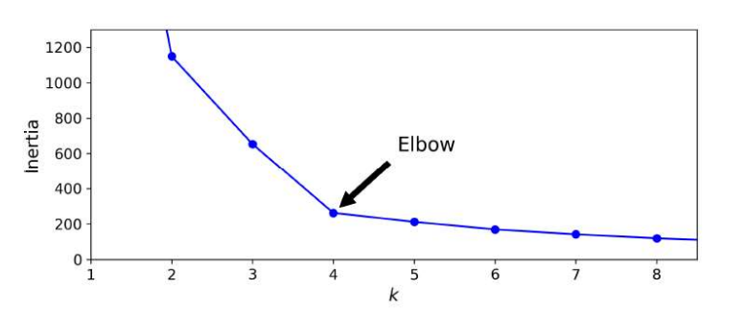

Challenges and improvements in K-Means:

1. We need to specify the number of cluster beforehand.
2. Running of algorithm multiple times to avoid a sub-optimal solution.
3. K-means doesn’t perform well when the data varying size, different density or non-spherical shape.
4. The cluster varies based on internal choice of centroids.
5. An improvement of K mean cluster is **K-Mean++** in this K-mean++ there is a smarter initialization steps that tends to select centroids that are distinct from one another.
6. An improvement is that it considerably accelerates the algorithm by avoiding many unnecessary distance calculations.
7. An improvement is that instead of using full dataset at each iteration, the algorithm is capable of using **mini-batches,** moving the centroids just slightly at each iterations as the result the speed will be increasing.

**Hierarchical Clustering:**

Introduction: One main disadvantage of k-means is that it needs is to pre-determine the number of clusters (K). Hierarchical clustering is an alternative approach which does not need us to give the value of K in advance to the model and also it create a beautiful tree-based structure for visualization.

This clustering algorithm is based on bottom up approach or agglomerative approach of cluster building. The algorithm starts with considering all the points as separate clusters and then grouping points together to form other clusters.

**The algorithm:**

1. Begin with n observations and a measure (such as Euclidean distance) of all the n(n-1)/2.
2. Compare all the distance and put the two closest clusters in the same cluster.
3. Dissimilarities between two cluster indicates the height in the dendrogram at which the fusion lines should be placed.
4. Compute the new pair wise inter-cluster dissimilarities among the remaining clusters.
5. Repeat steps 2 and 3 till we have only one cluster left.

Note:

1. The idea behind this linkage clustering or hierarchical clustering is to put things that are close together into same cluster. Linkage clustering is based on distance only.
2. We can cut dendrogram to form a flat clusters.

**Linkage methods:**

Hierarchical clustering start without clusters consisting of individual points. After that is compares clusters with each other and merges the two closest clusters. Since we are merging the cluster points there are linkage methods:

1. Single linkage: cluster distance = smallest pair wise distance
2. Complete linkage: cluster distance = large pair wise distance
3. Average linkage: cluster distance = average pair wise distance
4. Centroid linkage: cluster distance = distance between the centroids of the clusters
5. Ward’s linkage: cluster criteria = minimize the variance of the cluster.

**DBSCAN(Density Based Spatial Clustering of applications with noise):**

It is an unsupervised machine learning algorithm. This algorithm defines the clusters as continuous regions of high density.

Parameters are:

* Epsilon: this is called as eps. This is the distance till which we look for the neighboring points.
* Min_points: the minimum number of points specified by the users.
* Core_points: If the number of points inside the eps radius of point is greater than or equal to the min_points then it called as core point.
* Border points: if the number of points inside the eps radius of a point is less than the min_points and it lies within the eps radius region of the core point it is called border point.
* Noise: A point which is neither a core nor a border point is a noise point.

Algorithm steps:

1. The algorithm start with a data point in the dataset which has not been visited yet and its neighboring points are identified based on eps value.
2. If the point contain greater than or equal points than the min_pts, then the cluster formation starts and this point become a _core point _, else it’s considered as noise.
3. If the point is a core point, then all its neighbor become a part of cluster. If the points in the neighborhood turn out to become a core point then their neighbor is also a part of cluster.
4. Repeat the above steps until all points are classified into different c;usters or noise.

This algorithm works well if all the clusters are dense enough, and they are well separated by low density regions.

In short DBSCAN is a very simple yet powerful algorithm, capable of identifying any number of clusters, of any shape, it is robust to outliers, and it has just two parameters (eps and min_samples). However, if the density varies significantly across the clusters, it can be impossible for it to capture all the clusters properly. Moreover, its computational complexity is roughly O(m log m), making it pretty close to linear with regards to the number of instances.

**Evaluations of clusters:**

1. Cluster validity: the validation of a cluster created is a troublesome task. The problems here is: “clusters are in the eyes of the beholder” A good cluster will have:
   1. High inter-class similarity
   2. Low inter-class similarity

Aspects of cluster validations:

* + External: compare your cluster to the ground truth.
  + Internal: evaluating the cluster without reference of external data.
  + Reliability: the cluster is not formed by a chance some statistical frame work can be used.

External measures:

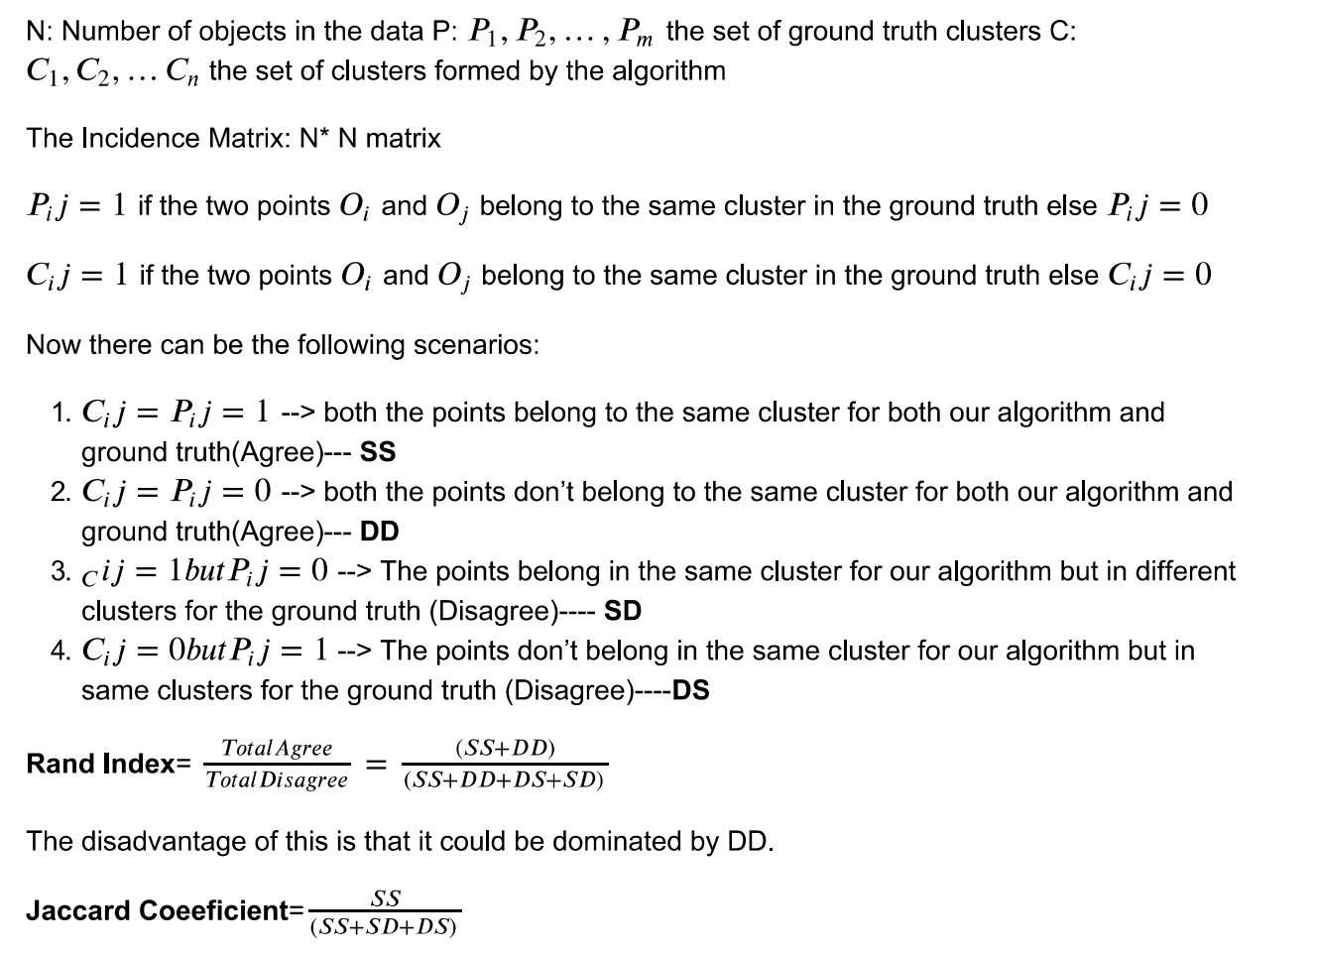

A higher value of Rand index and jaccard’s coefficient means that the clusters generated by our algorithm mostly agree to the ground truth.

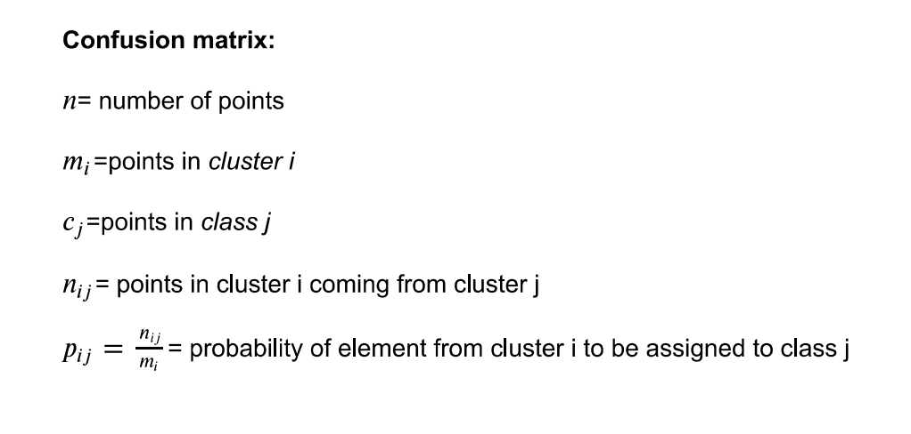

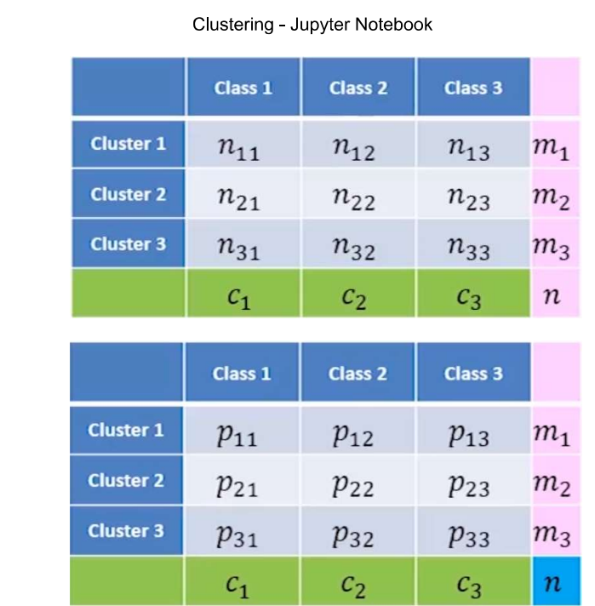

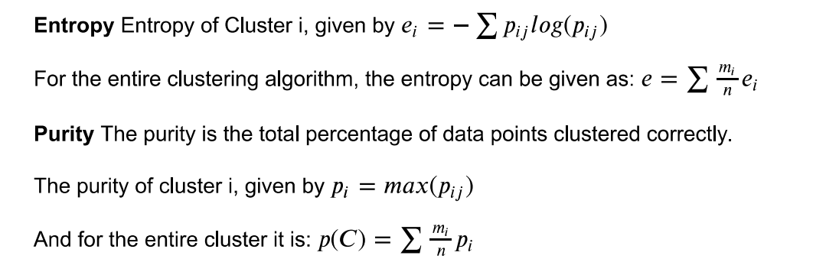

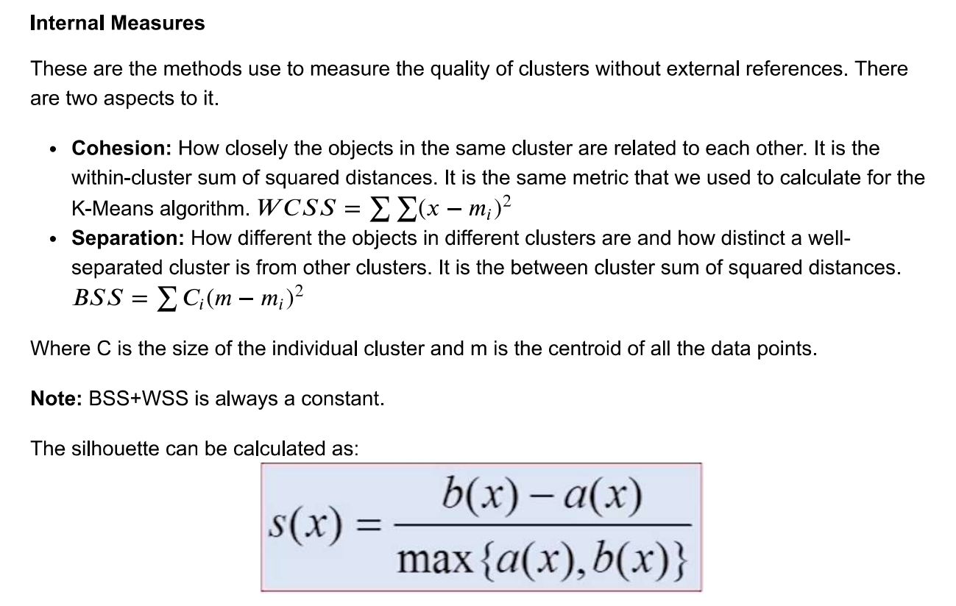

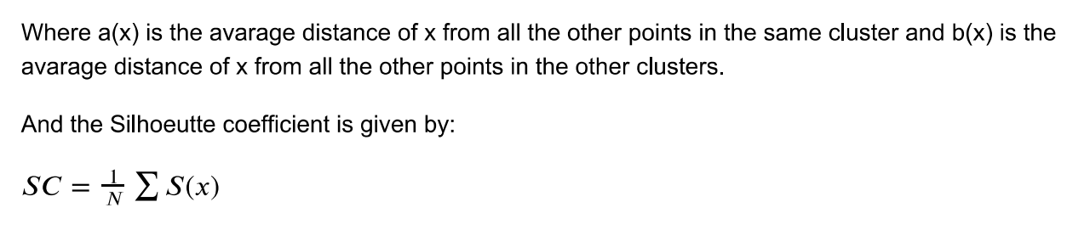

Page no 398